SIMATS ENGINEERING

CSA4307
INTERNET PROGRAMMING

CO2 - ASSESSMENT TOOL 1
Integrated Experiments

BAVANI SRI M

Code of Conduct
I C. Dharshini (192311400) that this submission is my original work and that I have adhered to the guidelines specified for this assessment. I understand that any violation of academic integrity rules will result in disciplinary action.

Signature of the student: C. Dharshini

EXPERIMENT 1: RESPONSIVE LAYOUT DESIGN
Aim: To analyze the causes of non-responsive website layouts and develop a responsive retail webpage using CSS Flexbox, media queries, and appropriate spacing and alignment techniques for mobile, tablet, and desktop devices.

(a) Analyze the possible reasons for lack of responsiveness
A responsive website automatically adjusts its structure, content, images, and navigation according to the screen size and device being used. A retail website that does not support responsive design may display misaligned elements, overlapping sections, horizontal scrolling, and unreadable text.
- Fixed-width elements: Fixed dimensions such as width: 1200px force a webpage to remain wide even on mobile screens, causing horizontal scrolling.
- Absence of viewport configuration: Without the viewport meta tag, mobile browsers may render the page using a wider virtual viewport, making text and content appear too small.
- Improper CSS positioning: Excessive use of position: absolute removes elements from normal document flow and can cause overlapping when screen dimensions change.
- Inappropriate navigation layout: A horizontal navigation bar with many links may exceed the width available on mobile screens.
- Fixed image dimensions: Product images with fixed width and height may extend beyond containers or become distorted.
- Incorrect margin and padding: Large margins, inconsistent padding, and negative margins can create uneven spacing and misalignment.
- Lack of media queries: Without media queries, the webpage cannot apply different layout rules at specific screen widths.
- Improper box model: Under content-box, padding and borders increase the total rendered width beyond the declared width.
- Non-flexible content sections: Fixed columns prevent content from rearranging naturally when the viewport changes.
- Insufficient testing: A page tested only on desktop may contain problems that become visible on tablets and smartphones.
Therefore, the website should be redesigned using flexible dimensions, responsive breakpoints, appropriate layout systems, and consistent spacing rules.

(b) Design a responsive webpage using CSS Flexbox
The proposed retail website contains a header, navigation bar, main product section, sidebar for special offers, and footer. Flexbox arranges the products and content sections, while flexible widths allow elements to adapt to available screen space.

(c) Demonstrate adaptation using media queries
- Desktop (above 1024px): Product cards can appear in four columns, with the offers sidebar alongside the products.
- Tablet (601px to 1024px): The sidebar moves below the product section and products are displayed in two columns.
- Mobile (600px or below): Each product occupies one row, and navigation links wrap into multiple lines.
The viewport meta tag ensures that the layout uses the device's actual screen width.

(d) Implement spacing, alignment, and distribution
- display: flex arranges elements in a flexible row or column.
- flex-wrap: wrap moves items onto new lines when space is insufficient.
- justify-content: space-between distributes available space between items.
- align-items: center aligns items along the cross-axis.
- gap maintains consistent spacing between products.
- padding creates internal space inside containers; margin separates neighboring elements.
- box-sizing: border-box includes padding and borders within declared dimensions.
- max-width: 100% prevents images from overflowing their containers.

Complete Program: Responsive Retail Website
Save the following program as responsive.html and open it in a web browser.
<!DOCTYPE html>
<html lang="en">
<head>
<meta charset="UTF-8">
<meta name="viewport"
content="width=device-width, initial-scale=1.0">
<title>ShopZone - Online Retail Store</title>

<style>
* {
box-sizing: border-box;
margin: 0;
padding: 0;
}

body {
font-family: Arial, sans-serif;
line-height: 1.6;
background: #f5f6fa;
color: #222;
}

header {
background: #172554;
color: white;
padding: 20px 5%;
display: flex;
justify-content: space-between;
align-items: center;
flex-wrap: wrap;
gap: 12px;
}

header h1 { font-size: 28px; }
header p { font-size: 14px; }

nav {
display: flex;
justify-content: center;
align-items: center;
flex-wrap: wrap;
gap: 12px;
padding: 15px;
background: #dbeafe;
}

nav a {
color: #172554;
text-decoration: none;
padding: 8px 16px;
border-radius: 5px;
font-weight: bold;
}

nav a:hover {
background: #172554;
color: white;
}

.container {
display: flex;
align-items: flex-start;
gap: 24px;
padding: 25px 5%;
}

.products { flex: 3; min-width: 0; }
.products h2, .sidebar h2 { margin-bottom: 18px; }

.product-list {
display: flex;
flex-wrap: wrap;
gap: 20px;
}

.product {
flex: 1 1 calc(25% - 20px);
min-width: 180px;
background: white;
padding: 15px;
border-radius: 8px;
box-shadow: 0 2px 7px #00000015;
}

.product img {
width: 100%;
height: 140px;
object-fit: contain;
display: block;
margin-bottom: 10px;
}

.product h3 { font-size: 17px; margin-bottom: 6px; }
.price { color: #166534; font-weight: bold; margin: 8px 0; }

.product button {
width: 100%;
border: none;
border-radius: 5px;
padding: 10px;
background: #2563eb;
color: white;
cursor: pointer;
}

.product button:hover { background: #1d4ed8; }

.sidebar {
flex: 1;
min-width: 200px;
background: white;
padding: 20px;
border-radius: 8px;
box-shadow: 0 2px 7px #00000015;
}

.sidebar p { margin-bottom: 12px; }

footer {
text-align: center;
background: #172554;
color: white;
padding: 20px;
margin-top: 15px;
}

@media (max-width: 1024px) {
.container { flex-direction: column; }
.products, .sidebar { width: 100%; }
.product { flex-basis: calc(50% - 10px); }
}

@media (max-width: 600px) {
header {
flex-direction: column;
text-align: center;
padding: 16px;
}

header h1 { font-size: 23px; }
nav { gap: 5px; padding: 10px; }

nav a {
padding: 8px 10px;
font-size: 14px;
}

.container { padding: 15px; gap: 18px; }
.product { flex-basis: 100%; min-width: 0; }
.product img { height: 180px; }
.sidebar { min-width: 0; padding: 15px; }
}
</style>
</head>

<body>
<header>
<h1>ShopZone</h1>
<p>Your One-Stop Online Shopping Store</p>
</header>

<nav>
<a href="#home">Home</a>
<a href="#products">Products</a>
<a href="#categories">Categories</a>
<a href="#offers">Offers</a>
<a href="#contact">Contact</a>
</nav>

<main class="container" id="home">
<section class="products" id="products">
<h2>Featured Products</h2>

<div class="product-list">
<article class="product">
<img src="https://placehold.co/300x200?text=Laptop"
alt="Laptop">
<h3>Laptop</h3>
<p>High-performance laptop for daily use.</p>
<p class="price">₹45,000</p>
<button type="button">Add to Cart</button>
</article>

<article class="product">
<img src="https://placehold.co/300x200?text=Headphones"
alt="Headphones">
<h3>Headphones</h3>
<p>Wireless headphones with clear sound.</p>
<p class="price">₹2,000</p>
<button type="button">Add to Cart</button>
</article>

<article class="product">
<img src="https://placehold.co/300x200?text=Smartphone"
alt="Smartphone">
<h3>Smartphone</h3>
<p>Modern smartphone with useful features.</p>
<p class="price">₹18,000</p>
<button type="button">Add to Cart</button>
</article>

<article class="product">
<img src="https://placehold.co/300x200?text=Smartwatch"
alt="Smartwatch">
<h3>Smartwatch</h3>
<p>Track your activities throughout the day.</p>
<p class="price">₹3,500</p>
<button type="button">Add to Cart</button>
</article>
</div>
</section>

<aside class="sidebar" id="offers">
<h2>Special Offers</h2>
<p>Get exciting discounts on selected products.</p>
<p>Free delivery on eligible orders.</p>
<p>Discover new arrivals at ShopZone!</p>
</aside>
</main>

<footer id="contact">
<p>Contact: support@shopzone.example</p>
<p>&copy; 2026 ShopZone. All rights reserved.</p>
</footer>
</body>
</html>

Expected Output
- Desktop: Header and navigation appear at the top. Product cards appear in a row when space permits, with the offers sidebar beside the products.
- Tablet: The offers sidebar moves below the products, and products appear in two columns.
- Mobile: The header becomes vertically aligned, navigation wraps, and each product occupies a separate row.

Explanation of the Program
- The viewport meta tag enables the webpage to adapt to the device width.
- The universal selector applies box-sizing: border-box and removes default margins and padding.
- Flexbox is used in the header, navigation bar, main layout, and product list.
- The flex property allocates available space between the product area and sidebar.
- The flex-wrap property allows product cards and navigation links to move to another line.
- The tablet media query changes the main layout to a vertical arrangement and uses two product columns.
- The mobile media query sets each product card to full width and reduces spacing.
- The object-fit: contain property prevents product images from being distorted.
- The min-width: 0 property allows flexible content containers to shrink without forcing horizontal overflow.
- Hover effects provide visual feedback for navigation links and buttons.

(e) Evaluate the responsive design
The redesigned website is more usable because its components adapt to different screen sizes without requiring separate webpages. Flexbox distributes available space, while media queries provide specific rules for tablets and mobile devices.
Test case | Expected result
Desktop at 1366px | Products and sidebar appear side by side.
Tablet at 768px | Products appear in two columns; sidebar moves below.
Mobile at 390px | Products appear in one column.
Resize the browser | Elements rearrange without overlapping.
Load large product images | Images remain within their cards.
View navigation on mobile | Links wrap instead of overflowing.

Further improvements: Add a working shopping cart, optimize images, use semantic HTML throughout the page, provide keyboard-accessible navigation, and test at intermediate widths such as 600px and 900px. A collapsible navigation menu can also be added for very narrow screens.
Result: A responsive retail webpage was developed successfully using CSS Flexbox, media queries, and consistent spacing and alignment techniques.

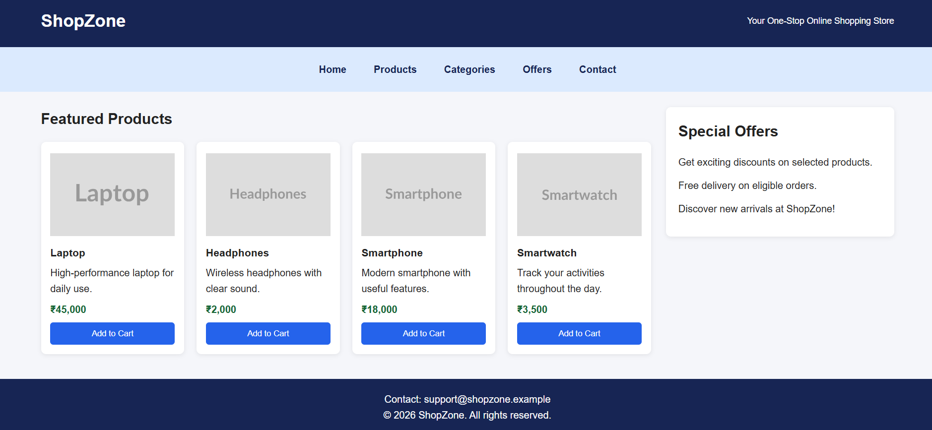
EXPERIMENT 2: FORM VALIDATION USING JAVASCRIPT
Aim: To develop a registration form that validates email addresses and phone numbers using HTML5 form attributes and JavaScript regular expressions, displays real-time error messages, and prevents invalid data from being submitted.

(a) Analyze the issues in the existing form validation mechanism
Form validation ensures that users enter information in the correct format before a registration form is processed. If validation is missing or incomplete, incorrect information may enter the application's database and affect subsequent operations.
- Invalid email formats: The form may accept values such as student@, student.com, or student@@gmail.com if it checks only whether the field contains text.
- Incorrect phone numbers: The form may accept alphabetic characters, numbers of the wrong length, or invalid prefixes.
- Missing required-field checks: Users may submit the form without entering essential information.
- No immediate feedback: If errors appear only after submission, users may struggle to identify which field needs correction.
- Improper event handling: A form may submit before validation or fail to prevent submission when validation fails.
- Lack of clear messages: Generic messages do not explain how to correct the problem.
- Client-side limitations: Browser-side checks can be bypassed, so they cannot be the application's only security mechanism.
The proposed form uses HTML5 attributes, regular expressions, real-time validation, and a clear submission status.

(b) Design input fields with appropriate HTML attributes
- Full Name: Uses required to prevent empty submissions.
- Email Address: Uses type=email for basic browser validation.
- Phone Number: Uses type=tel and maxlength=10 to support telephone entry and limit input length.
- Register Button: The form is processed only after built-in constraints and JavaScript checks are satisfied.
The required, type, and maxlength attributes improve input quality. JavaScript implements the specific validation rules and provides real-time feedback.

(c) Regular-expression validation
Email validation pattern:
/^[^\s@]+@[^\s@]+\.[^\s@]+$/
This pattern checks for non-empty text before and after the @ symbol, followed by a dot and a domain portion. It is a basic check and does not implement every rule of the complete email standard.
Indian mobile number pattern:
/^[6-9]\d{9}$/
This pattern checks that the input contains exactly ten digits and begins with a digit from 6 to 9. It is a simplified format check, not proof that the number is active or belongs to the person registering.

(d) Develop real-time error messages
The input event runs validation whenever the user types or modifies a field. The blur event checks a field when the user leaves it. The submit event validates the entire form before displaying the success message.

Complete Program: Registration Form Validation
Save the following program as form-validation.html.
<!DOCTYPE html>
<html lang="en">
<head>
<meta charset="UTF-8">
<meta name="viewport"
content="width=device-width, initial-scale=1.0">
<title>Registration Form Validation</title>

<style>
* { box-sizing: border-box; }

body {
font-family: Arial, sans-serif;
background: #eef2f7;
margin: 0;
padding: 30px 15px;
}

.form-container {
max-width: 500px;
margin: auto;
background: white;
padding: 30px;
border-radius: 10px;
box-shadow: 0 4px 15px #00000018;
}

h2 {
text-align: center;
color: #1e3a8a;
margin-bottom: 25px;
}

.field { margin-bottom: 18px; }

label {
display: block;
font-weight: bold;
margin-bottom: 7px;
}

input {
width: 100%;
padding: 12px;
border: 1px solid #999;
border-radius: 5px;
font-size: 15px;
}

input:focus {
outline: 2px solid #93c5fd;
border-color: #2563eb;
}

input.invalid { border: 2px solid #dc2626; }
input.valid { border: 2px solid #15803d; }

.error {
color: #b91c1c;
font-size: 13px;
margin-top: 5px;
min-height: 16px;
}

button {
width: 100%;
padding: 12px;
background: #2563eb;
color: white;
border: none;
border-radius: 5px;
font-size: 16px;
cursor: pointer;
}

button:hover { background: #1d4ed8; }

#result {
text-align: center;
margin-top: 15px;
font-weight: bold;
}

.success { color: #15803d; }
.failure { color: #b91c1c; }
</style>
</head>

<body>
<div class="form-container">
<h2>Student Registration</h2>

<form id="registrationForm" novalidate>
<div class="field">
<label for="name">Full Name</label>
<input type="text" id="name" name="name"
required autocomplete="name"
aria-describedby="nameError">
<p class="error" id="nameError"
aria-live="polite"></p>
</div>

<div class="field">
<label for="email">Email Address</label>
<input type="email" id="email" name="email"
required autocomplete="email"
placeholder="student@example.com"
aria-describedby="emailError">
<p class="error" id="emailError"
aria-live="polite"></p>
</div>

<div class="field">
<label for="phone">Mobile Number</label>
<input type="tel" id="phone" name="phone"
required inputmode="numeric"
maxlength="10"
autocomplete="tel-national"
placeholder="10-digit mobile number"
aria-describedby="phoneError">
<p class="error" id="phoneError"
aria-live="polite"></p>
</div>

<button type="submit">Register</button>
<p id="result" role="status"
aria-live="polite"></p>
</form>
</div>

<script>
const form =
document.getElementById("registrationForm");
const nameInput = document.getElementById("name");
const emailInput = document.getElementById("email");
const phoneInput = document.getElementById("phone");
const result = document.getElementById("result");

function showError(input, errorId, message) {
document.getElementById(errorId).textContent =
message;

input.classList.toggle("invalid", message !== "");
input.classList.toggle("valid", message === "");
input.setAttribute("aria-invalid",
message !== "" ? "true" : "false");
}

function validateName() {
const value = nameInput.value.trim();

if (value === "") {
showError(nameInput, "nameError",
"Please enter your full name.");
return false;
}

if (value.length < 3) {
showError(nameInput, "nameError",
"Name must contain at least 3 characters.");
return false;
}

showError(nameInput, "nameError", "");
return true;
}

function validateEmail() {
const value = emailInput.value.trim();
const pattern = /^[^\s@]+@[^\s@]+\.[^\s@]+$/;

if (value === "") {
showError(emailInput, "emailError",
"Email address is required.");
return false;
}

if (!pattern.test(value)) {
showError(emailInput, "emailError",
"Enter a valid email address.");
return false;
}

showError(emailInput, "emailError", "");
return true;
}

function validatePhone() {
const value = phoneInput.value;
const pattern = /^[6-9]\d{9}$/;

if (value === "") {
showError(phoneInput, "phoneError",
"Mobile number is required.");
return false;
}

if (!pattern.test(value)) {
showError(phoneInput, "phoneError",
"Enter a valid 10-digit Indian mobile number.");
return false;
}

showError(phoneInput, "phoneError", "");
return true;
}

nameInput.addEventListener("input", validateName);
emailInput.addEventListener("input", validateEmail);
phoneInput.addEventListener("input", validatePhone);

form.addEventListener("submit", function(event) {
event.preventDefault();

const nameValid = validateName();
const emailValid = validateEmail();
const phoneValid = validatePhone();

if (nameValid && emailValid && phoneValid) {
result.textContent =
"Registration successful! All fields are valid.";
result.className = "success";
} else {
result.textContent =
"Please correct the errors before submitting.";
result.className = "failure";
}
});
</script>
</body>
</html>

Explanation of the Program
- HTML structure: The form contains name, email, and phone fields, each with a label and dedicated error-message area.
- CSS styling: The form is centered, has a maximum width, and uses borders and spacing to improve readability.
- Name validation: trim() removes leading and trailing whitespace. The function rejects an empty name or a name shorter than three characters.
- Email validation: The regular expression checks for a basic email format and rejects missing components.
- Phone validation: The regular expression verifies exactly ten digits and an Indian mobile-number prefix from 6 to 9.
- Real-time checking: Event listeners call validation functions as users enter or modify information.
- Error presentation: Invalid fields receive a red border and a descriptive error message. Valid fields receive a green border.
- Submission control: The submit handler calls all validation functions. The success message appears only if all checks pass.
- Accessibility: Labels identify inputs, and live regions help announce validation feedback to assistive technologies.

(e) Evaluate the validation system and suggest enhancements
The form improves data quality by identifying invalid information before the form is processed. Real-time error messages help users correct mistakes immediately, and field-specific feedback makes the form easier to understand.
- Server-side validation: Repeat all important validation checks on the server because client-side JavaScript can be disabled or bypassed.
- Email verification: Send a verification link to confirm that the user can access the supplied email address.
- Phone verification: Use an OTP when verified phone ownership is required.
- Better error handling: Move keyboard focus to the first invalid field after submission and preserve valid entries.
- Accessible feedback: Use clear labels, aria-invalid, and aria-describedby to associate errors with the appropriate inputs.
- Security measures: Apply rate limiting, secure session handling, and appropriate protection against automated submissions.
- Privacy protection: Avoid logging unnecessary personal information and protect stored registration data.
- Comprehensive testing: Test empty values, malformed emails, incorrect phone lengths, whitespace, and boundary cases.
The system should not rely exclusively on regular expressions. Real-world email formats have additional rules, and a format-valid phone number does not prove that the number exists.
Result: A registration form was implemented successfully using HTML5 input attributes, JavaScript regular expressions, real-time error messages, and submission validation.
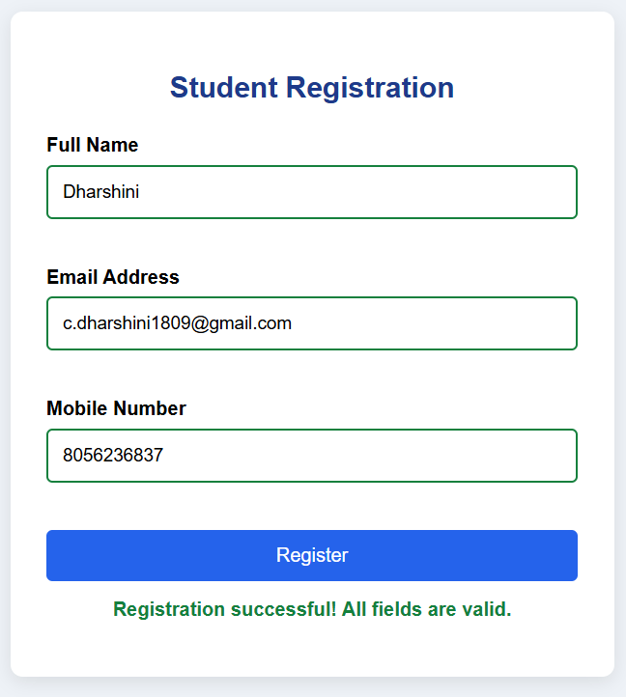

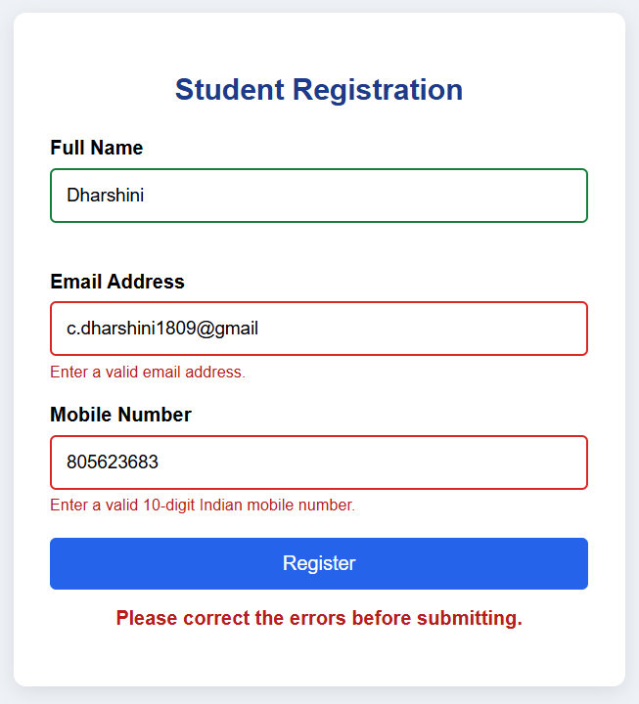

EXPERIMENT 3: CSS LAYOUT DEBUGGING
Aim: To identify the causes of overlapping webpage elements and correct the layout using the CSS box model, positioning techniques, Flexbox, Grid, and responsive media queries.

(a) Analyze the CSS properties responsible for layout overlapping
CSS layout overlapping occurs when two or more elements occupy the same visual area or when content extends beyond its intended container. It can reduce readability, hide important information, and make the webpage difficult to use.
- Absolute positioning: position: absolute removes an element from normal document flow. Other elements do not reserve space for it, which can cause overlapping.
- Fixed width and height: Elements with fixed dimensions may not fit smaller viewports. A 1200px-wide container may extend beyond a mobile screen.
- Negative margins: Negative margins move elements toward or over neighboring elements, potentially causing collisions.
- Incorrect z-index: z-index controls stacking order for positioned elements and certain other layout contexts. A higher stacking level may cover another element.
- Overflow problems: Long text, wide images, or large child elements can extend beyond parent containers if dimensions are not controlled.
- Box model miscalculations: Under content-box, padding and borders are added to the declared content width.
- Improper Flexbox and Grid configuration: Incorrect column widths, minimum sizes, and gaps can force elements outside their available space.
- Missing responsive rules: Without media queries or flexible dimensions, desktop layouts may remain unchanged on smaller devices.
To correct these issues, the layout should use normal document flow wherever possible, flexible sizing, appropriate positioning, and responsive breakpoints.

(b) Examine the role of the CSS box model
- Content: The actual text, image, or other information inside the element.
- Padding: Space between the content and the border.
- Border: The line surrounding the content and padding.
- Margin: External space separating the element from neighboring elements.
Consider the following CSS:
.box {
width: 300px;
padding: 20px;
border: 5px solid black;
margin: 10px;
}
Under the default content-box model, content width is 300px, horizontal padding is 40px, and horizontal borders total 10px. The rendered width excluding margins is 350px; including 10px margins on both sides, total horizontal space is 370px.
Using box-sizing: border-box makes sizing more predictable because the declared width includes padding and borders.
* {
box-sizing: border-box;
}
With border-box, an element declared as 300px wide remains 300px wide, excluding margins.

(c) Debug using positioning, Flexbox, and Grid
Technique | Purpose | Appropriate use
position: relative | Positions an element relative to its normal location. | Small visual adjustments or positioning a child element.
position: absolute | Positions an element relative to its containing block. | Badges, overlays, and decorative elements.
Flexbox | Arranges elements along one primary axis. | Navigation bars, toolbars, and flexible rows.
CSS Grid | Organizes content into rows and columns. | Main content and sidebar layouts.
Media queries | Apply CSS rules at specific viewport widths. | Rearranging layouts on mobile devices.

The main content and sidebar will use CSS Grid. Flexbox will arrange navigation links, while normal document flow prevents the footer from overlapping the main content. Absolute positioning is reserved for a notification badge.

(d) Modify the CSS to correct overlapping during resizing
Save the following program as layout-debug.html.
<!DOCTYPE html>
<html lang="en">
<head>
<meta charset="UTF-8">
<meta name="viewport"
content="width=device-width, initial-scale=1.0">
<title>CSS Layout Debugging</title>

<style>
* { box-sizing: border-box; }

body {
margin: 0;
font-family: Arial, sans-serif;
line-height: 1.6;
color: #222;
background: #f1f5f9;
}

header {
background: #1e293b;
color: white;
padding: 20px 5%;
text-align: center;
}

nav {
display: flex;
justify-content: center;
align-items: center;
flex-wrap: wrap;
gap: 12px;
padding: 15px;
background: #dbeafe;
}

nav a {
text-decoration: none;
color: #1e293b;
padding: 8px 14px;
font-weight: bold;
}

nav a:hover {
background: #bfdbfe;
border-radius: 5px;
}

.layout {
display: grid;
grid-template-columns:
minmax(0, 2fr) minmax(220px, 1fr);
gap: 24px;
max-width: 1200px;
margin: 0 auto;
padding: 25px;
align-items: start;
}

.content {
min-width: 0;
background: white;
padding: 24px;
border-radius: 8px;
overflow-wrap: anywhere;
}

.content h2 {
margin-top: 0;
color: #1d4ed8;
}

.content p { margin-bottom: 16px; }

.content img {
display: block;
width: 100%;
max-width: 100%;
height: auto;
margin: 15px 0;
border-radius: 6px;
}

.sidebar {
min-width: 0;
padding: 20px;
background: #e2e8f0;
border-radius: 8px;
overflow-wrap: anywhere;
}

.sidebar h3 { margin-top: 0; }

.notice {
position: relative;
margin-top: 20px;
padding: 25px 15px 15px;
background: #dcfce7;
border-radius: 6px;
}

.badge {
position: absolute;
top: 5px;
right: 8px;
background: #166534;
color: white;
padding: 2px 8px;
border-radius: 4px;
font-size: 12px;
}

footer {
background: #1e293b;
color: white;
text-align: center;
padding: 20px;
}

@media (max-width: 800px) {
.layout {
grid-template-columns: 1fr;
padding: 20px;
gap: 18px;
}

.content, .sidebar { width: 100%; }
}

@media (max-width: 480px) {
header { padding: 15px 10px; }
header h1 { font-size: 23px; }
nav { gap: 4px; padding: 10px; }

nav a {
padding: 7px 9px;
font-size: 14px;
}

.layout { padding: 12px; gap: 12px; }

.content, .sidebar { padding: 15px; }

.notice { padding: 30px 10px 10px; }
}
</style>
</head>

<body>
<header>
<h1>CSS Layout Debugging</h1>
<p>A responsive webpage without overlapping elements</p>
</header>

<nav>
<a href="#home">Home</a>
<a href="#content">Content</a>
<a href="#sidebar">Sidebar</a>
<a href="#footer">Contact</a>
</nav>

<main class="layout" id="home">
<section class="content" id="content">
<h2>Main Content Area</h2>

<p>
This section displays the primary information
of the webpage. CSS Grid provides a flexible
layout that adapts to the available screen width.
</p>

<img src="https://placehold.co/700x250?text=Main+Content"
alt="Illustration of the main content area">

<p>
Flexible widths, proper spacing, and the box
model prevent the content from extending beyond
its container when the browser is resized.
</p>

<div class="notice">
<span class="badge">NEW</span>
<strong>Layout improvement</strong>
<p>
This notification is positioned inside its
container without covering the main content.
</p>
</div>
</section>

<aside class="sidebar" id="sidebar">
<h3>Sidebar Information</h3>
<p>
The sidebar displays supplementary information,
announcements, or related links.
</p>
<p>
On smaller screens, it moves below the main
content instead of squeezing the content area.
</p>
</aside>
</main>

<footer id="footer">
<p>&copy; 2026 CSS Layout Debugging Project</p>
<p>Designed using HTML5 and CSS3</p>
</footer>
</body>
</html>

Explanation of the Program
- Universal box sizing: box-sizing: border-box makes dimensions predictable by including padding and borders within the declared width.
- Header and navigation: The header uses centered text, while Flexbox arranges navigation links and allows them to wrap.
- Grid-based main layout: grid-template-columns allocates approximately two parts of space to the main content and one part to the sidebar.
- Minimum track sizing: minmax(0, 2fr) allows the main column to shrink below its automatic minimum content size, helping prevent long content from forcing horizontal overflow.
- Consistent spacing: gap creates space between columns without relying on negative margins.
- Responsive images: width: 100% and max-width: 100% keep the image within its parent container.
- Text overflow handling: overflow-wrap: anywhere allows long strings to wrap rather than extend beyond the container.
- Relative positioning: The notice container uses position: relative as the positioning reference for its badge.
- Absolute positioning: The badge uses position: absolute to sit in the top-right corner of the notification. The parent reserves space for it, so it does not interfere with the main page layout.
- Tablet media query: At widths of 800px or below, the main layout changes from two columns to one.
- Mobile media query: At widths of 480px or below, padding and navigation spacing are reduced.
- Footer positioning: The footer remains in normal document flow, so it appears after the main content.

(e) Evaluate the corrected layout and suggest best practices
The corrected webpage maintains a clear separation between the main content and sidebar. On desktop screens, CSS Grid provides a two-column arrangement. On tablet and mobile screens, media queries change the layout to one column. Flexible sizing and controlled image dimensions reduce horizontal overflow.
Test case | Expected result
Desktop at 1366px | Main content and sidebar appear side by side.
Tablet at 768px | Sidebar moves below the main content.
Mobile at 390px | Content occupies a single column.
Long text inside a section | Text wraps within the container.
Large image | Image stays within the content area.
Notification badge | Badge stays inside the notification container.
Browser resizing | No unintended overlap between main sections.
Footer placement | Footer remains below the content.

